**AI TRAFFIC MONITORING**

# A PROJCT REPORT

***Submitted by***

|  |
| --- |
| **ADITHYA A** |
| **BHARATH P** |
| **DHARANEESHWARAN V** |
| **HARIHARAN P** |

***in partial fulfilment for the award of the degree***

***of***

# BACHELOR OF TECHNOLOGY

**IN**

## ARTIFICIAL INTELLIGENCE AND DATA SCIENCE

 **K. RAMAKRISHNAN COLLEGE OF**

**ENGINEERING**

**(AUTONOMOUS)**

**SAMAYAPURAM, TRICHY**

  **ANNA UNIVERSITY**

# CHENNAI 600 025

**DECEMBER 2024**

**AI TRAFFIC MONITORIN**



**AI TRAFFIC MONITORING**

**AGB1211 DESIGN THINKING**

***Submitted by***

|  |  |
| --- | --- |
| **ADITHYA A** | **(8115U23AD301)** |
| **BHARATH P** | **(8115U23AD302)** |
| **DHARANEESHWARAN V** | **(8115U23AD303)** |
| **HARIHARAN P** | **(8115U23AD306)** |

***in partial fulfilment for the award of the degree***

***of***

# BACHELOR OF TECHNOLOGY

**IN**

**ARTIFICIAL INTELLIGENCE AND DATA SCIENCE**

**Under the Guidance of**

## Mrs. RANI. C

DEPARTMENT OF ARTIFICIAL INTELLIGENCE AND DATA SCIENCE

K. RAMAKRISHNAN COLLEGE OF ENGINEERING

 **K. RAMAKRISHNAN COLLEGE OF ENGINEERING**

**(AUTONOMOUS)**

**Under**

**ANNA UNIVERSITY, CHENNAI**

**K. RAMAKRISHNAN COLLEGE OF ENGINEERING**

**(AUTONOMOUS)**

**Under**

**ANNA UNIVERSITY, CHENNAI**

## BONAFIDE CERTIFICATE

Certified that this project report titled **“AI TRAFFIC MONITORING”** i**s** the bonafide work of **ADITHYA A (8115U23AD301), BHARATH P (8115U23AD302), DHARANEESHWARAN V (8115U23AD303), HARIHARAN P(8115U23AD306)** who carried out the work under my supervision.

|  |  |
| --- | --- |
|  |  |
| **Dr. B.KIRAN BALA, M.E., Ph.D.,** | **Mrs. C.RANI, M.E.,** |
| **HEAD OF THE DEPARTMENT,** | **SUPERVISOR,** |
| Department of Artificial Intelligence  and Data Science, | Department of Artificial Intelligence  and Data Science, |
| K. Ramakrishnan College of Engineering, | K. Ramakrishnan College of Engineering, |
| Samayapuram, Trichy-621 112.  . | Samayapuram, Trichy-621 112. |

**SIGNATURE OF INTERNAL EXAMINER**  **SIGNATURE OF EXTERNAL EXAMINER**

**NAME: NAME:**

**DATE: DATE:**

**K. RAMAKRISHNAN COLLEGE OF ENGINEERING**

**(AUTONOMOUS)**

**Under**

## ANNA UNIVERSITY, CHENNAI

**DECLARATION BY THE CANDIDATES**

We declare that to the best of our knowledge the work reported here in has been composed solely by ourselves and that it has not been in whole or in part in any previous application for a degree.

Submitted for the project Viva- Voce held at K. Ramakrishnan College of Engineering on

____________.

**SIGNATURE OF THE CANDIDATES**

# ACKNOWLEDGEMENT

We thank the almighty GOD, without whom it would not have been possible for us to complete our project.

I extend our sincere acknowledgment and appreciation to the esteemed and honourable Chairman, **Dr. K. RAMAKRISHNAN, B.E.,** for having provided the facilities during the course of our study in college.

We extend our hearty gratitude and thanks to our honorable and grateful Executive Director **Dr.S.KUPPUSAMY, B.Sc.,MBA., Ph.D.,** K. Ramakrishnan College of Engineering(Autonomous).

We are glad to thank our Principal **Dr.D.SRINIVASAN, M.E., Ph.D., FIE., MIIW., MISTE., MISAE., C.Engg,** for giving us permission to carry out this project.

We wish to convey our sincere thanks to **Dr.B.KIRAN BALA, B.Tech., M.E., M.B.A., Ph.D.,** Head of the Department, Artificial Intelligence and Data Science for giving us constant encouragement and advice throughout the course.

We are grateful to **C.RANI, M.E.,** Artificial Intelligence and Data Science, K. Ramakrishnan College of Engineering (Autonomous), for her guidance and valuable suggestions during the course of study.

Finally, we sincerely acknowledged in no less terms all our staff members, our parents and, friends for their co-operation and help at various stages of this project work.

|  |  |
| --- | --- |
| **ADITHYA A** | **8115U23AD301** |
| **BHARATH P** | **8115U23AD302** |
| **DHARANEESHWARAN V** | **8115U23AD303** |
| **HARIHARAN P** | **8115U23AD306** |

**DEPARTMENT OF ARTIFICIAL INTELLIGENCE AND**

**DATA SCIENCE**

**VISION OF THE INSTITUTION**

To achieve a prominent position among the top technical institutions.

**MISSION OF THE INSTITUTION**

M1: To bestow standard technical education par excellence through state of the art

infrastructure, competent faculty and high ethical standards.

M2: To nurture research and entrepreneurial skills among students in cutting edge technologies.

M3: To provide education for developing high-quality professionals to transform the society.

**VISION OF THE DEPARTMENT**

To prove excellence in Data Science research, education and innovation with AI tools.

**MISSION OF THE DEPARTMENT**

M1: To contribute for greater collaboration with academia and businesses.

M2: To impart quality and research based education to promote innovations providing smart solutions in multi-disciplinary area of Artificial Intelligence and Data Science.

M3: To provide eminent Data Scientists to serve humanity

**PROGRAM EDUCATIONAL OBJECTIVES (PEOS)**

Our graduates shall

PEO1: To create Graduates with successful career in the field of Data Science in all industries or pursue higher education and research or evolve as entrepreneur.

PEO2: To equip the Graduates with the ability and attitude to adapt to emerging technological changes in the field of expert systems.

PEO3: To excel the students as socially committed engineers with high ethical values, leadership qualities and openness for the needs of society.

**PROGRAM OUTCOMES**

Engineering students will be able to:

1. **Engineering knowledge:** Apply the knowledge of mathematics, science, engineering fundamentals, and an engineering specialization to the solution of complex engineering problems.
2. **Problem analysis:** Identify, formulate, review research literature, and analyze complex engineering problems reaching substantiated conclusions using first principles of mathematics, natural sciences, and engineering sciences.
3. **Design/development of solutions:** Design solutions for complex engineering problems and design system components or processes that meet the specified needs with appropriate consideration for the public health and safety, and the cultural, societal, and environmental considerations.
4. **Conduct investigations of complex problems:** Use research-based knowledge and research methods including design of experiments, analysis and interpretation of data, and synthesis of the information to provide valid conclusions.
5. **Modern tool usage:** Create, select, and apply appropriate techniques, resources, and modern engineering and IT tools including prediction and modeling to complex engineering activities with an understanding of the limitations.
6. **The engineer and society:** Apply reasoning informed by the contextual knowledge to assess societal, health, safety, legal and cultural issues and the consequent responsibilities relevant to the professional engineering practice.
7. **Environment and sustainability:** Understand the impact of the professional engineering solutions in societal and environmental contexts, and demonstrate the knowledge of, and need for sustainable development.
8. **Ethics:** Apply ethical principles and commit to professional ethics and responsibilities and norms of the engineering practice.
9. **Individual and team work:** Function effectively as an individual, and as a member or leader in diverse teams, and in multidisciplinary settings.
10. **Communication:** Communicate effectively on complex engineering activities with the engineering community and with society at large, such as, being able to comprehend and write effective reports and design documentation, make effective presentations, and give and receive clear instructions.
11. **Project management and finance:** Demonstrate knowledge and understanding of the engineering and management principles and apply these to one’s own work, as a member and leader in a team, to manage projects and in multidisciplinary environments.
12. **Life-long learning:** Recognize the need for, and have the preparation and ability to engage in independent and life-long learning in the broadest context of technological change.

**PROGRAM SPECIFIC OUTCOMES (PSOs)**

* **PSO1:** To develop optimized Data Science Solutions, through analysis, design, implementation, and evaluation to give technological solutions for real-time societal issues.
* **PSO2:** To employ advanced analytic platforms in creating innovative career paths to become best data scientists.

**ABSTRACT**

The AI Traffic Monitoring System is an advanced solution designed to enhance the efficiency of urban traffic management by integrating artificial intelligence, machine learning, and computer vision technologies. This system collects real-time data from various sources such as traffic cameras, sensors, and connected vehicles to monitor traffic conditions, detect congestion, and identify incidents. By analyzing this data with AI algorithms, the system can make intelligent decisions to optimize traffic flow, such as adjusting traffic signal timings, recommending alternative routes to drivers, and providing real-time updates to public transportation networks. One of the core functions is the dynamic adjustment of traffic signals based on traffic volume and flow, reducing delays and preventing bottlenecks at intersections and the system’s predictive analytics capabilities allow for forecasting traffic conditions and preemptively adjusting the infrastructure to minimize congestion before it occurs. AI-based incident detection further enhances safety by identifying accidents, stalled vehicles, or road blockages and automatically notifying authorities for quicker intervention.

|  |  |  |
| --- | --- | --- |
| **CHAPTER**  **No.** | **TITLE** | **PAGE**  **No.** |
|  | **ABSTRACT** | ix |
| **1** | **INTRODUCTION** | 1 |
|  | 1.1 Introduction | 1 |
|  | 1.2 Problem statement | 2 |
|  | 1.3 Objective | 3 |
| **2** | **PROJECT METHODOLOGY** | 5 |
|  | 2.1 Project Methodology | 5 |
|  | 2.2 Block Diagram | 8 |
| **3** | **KEY PHASES OF DESIGN THINKING** | 9 |
|  | 3.1 Empathize | 9 |
|  | 3.2 Define | 10 |
|  | 3.3 Ideate | 11 |
|  | 3.4 Prototype | 12 |
|  | 3.5 Test | 13 |
| **4** | **MODULE DESCRIPTION** | 14 |
|  | 4.1 Vehicle Detection and Classification | 14 |
|  | 4.2 Automated Number Plate Recognition | 15 |
|  | 4.3 Traffic Flow ant Optimization Module | 16 |
| **5** | **CONCLUSION** | 17 |
|  | **REFERENCES** | 18 |
|  | **APPENDIX A – SCREENSHOTS** | 19 |

# TABLE OF CONTENT

**CHAPTER 1**

**INTRODUCTION**

**1.1 Introduction**

Urban traffic management is a critical challenge faced by cities worldwide due to increasing population density, vehicle numbers, and the complexity of transportation networks. Traditional traffic management systems, primarily relying on fixed infrastructure such as traffic lights, road signs, and manual surveillance, struggle to keep pace with the growing demand for efficiency, safety, and real-time responsiveness. These conventional methods are often reactive rather than proactive, addressing traffic congestion or incidents only after they occur, leading to inefficiencies, delays, and increased risks.

In response to these challenges, AI-based traffic monitoring and management systems have emerged as a transformative solution. These systems harness the power of advanced artificial intelligence technologies, including computer vision, machine learning, and data analytics, to automate and optimize traffic management processes. AI-enabled systems can monitor traffic in real time, process large volumes of data from various sources such as cameras, sensors, and GPS devices, and make informed decisions to improve traffic flow, reduce accidents, and enhance public safety.

By utilizing tools such as computer vision, machine learning, and optical character recognition (OCR), these systems can efficiently monitor real-time traffic conditions, detect violations, and provide actionable insights. Key components include surveillance cameras, sensors, and drones for data collection, coupled with AI algorithms for processing and decision-making. This technology not only optimizes traffic flow but also automates tasks like identifying vehicles through number plate recognition, detecting rule violations, and generating reports for long-term traffic planning. As urbanization increases, AI traffic monitoring plays a vital role in building smarter, safer, and more efficient transportation systems.

## 1.2 Problem Statement

Urban traffic congestion and inefficient traffic management have become significant challenges in modern cities worldwide. As the global population continues to grow and the number of vehicles on the road increases, traditional traffic management systems—often relying on manual oversight and static infrastructure—are no longer sufficient to handle the complexities of modern traffic patterns.

These systems struggle to respond in real-time to dynamic traffic conditions, leading to increased congestion, longer travel times, higher accident rates, and environmental degradation due to excessive fuel consumption and emissions.

Moreover, traffic violations, such as speeding, illegal parking, and running red lights, often go unnoticed or unaddressed in real time, compromising public safety and undermining enforcement efforts. Traditional methods of monitoring traffic, such as human patrols or fixed sensors, can be resource-intensive, slow to react, and prone to errors, resulting in inefficiencies in both traffic management and law enforcement.

The lack of a comprehensive, automated, and real-time solution for monitoring and managing traffic flows exacerbates these issues. Existing traffic systems are limited in their ability to optimize traffic signals dynamically based on real-time traffic conditions or to predict and alleviate congestion before it occurs.

These inefficiencies highlight the need for a more intelligent and automated approach to traffic management. The lack of real-time data analysis and adaptive systems prevents authorities from optimizing traffic flow and responding swiftly to violations or emergencies.

Addressing these challenges requires the integration of AI-powered solutions, such as number plate recognition systems and real-time traffic monitoring, to enhance efficiency, ensure safety, and provide actionable insights for better urban planning and Traditional systems often rely on manual monitoring and fixed traffic signal schedules, which are insufficient to handle the dynamic nature of modern road networks. This has resulted in frequent traffic congestion, delays, and a rise in rule violations such as speeding, red-light breaches, and unauthorized parking.

**1.3** **Objective**

The primary goal of the AI Traffic Monitoring and Management System is to create an intelligent, real-time, and automated solution for managing urban traffic. With the increasing complexity of modern transportation networks, the need for efficient traffic flow, enhanced safety, and reduced environmental impact has never been more pressing. Traditional traffic management methods, which rely heavily on manual intervention and static infrastructure, are often insufficient to handle the challenges posed by growing traffic volumes, congestion, and accidents.

1. **Real-Time Traffic Monitoring and Data Collection:**

One of the core objectives is to develop a comprehensive traffic monitoring system that collects real-time data from various sources, including cameras, sensors, and GPS devices. By using AI-powered technologies, the system will be capable of continuously monitoring traffic conditions, vehicle movement, and congestion levels across urban areas. Real-time data collection will allow for a more accurate understanding of traffic patterns and provide the foundation for dynamic traffic management. Authorities will be able to respond quickly to changing traffic conditions, ensuring a more efficient transportation network.

1. **Automated Vehicle Detection and Classification:**

The system will incorporate machine learning algorithms, particularly convolutional neural networks (CNNs), to detect and classify vehicles based on their type, size, and movement. This will enable the system to automatically track various types of vehicles, such as cars, trucks, buses, and motorcycles, with high accuracy. By classifying vehicles in real time, the system will be able to provide detailed information about traffic composition, aiding in the analysis of traffic flow, congestion hotspots, and transportation demands. Automated vehicle classification will reduce the need for manual traffic surveys and ensure more accurate data.

1. **Automated Number Plate Recognition (ANPR) for Violation Detection:**

Anotherimportant objective is to integrate Automated Number Plate Recognition (ANPR) technology into the system. ANPR will enable the automatic reading of vehicle license plates, allowing for the identification of vehicles involved in traffic violations such as speeding, illegal parking, and running red lights. By automating the process of violation detection, the system will enhance law enforcement efficiency, providing real-time alerts to authorities and allowing for quicker responses. This will improve the enforcement of traffic regulations, reduce the number of violations, and contribute to road safety.

1. **Dynamic Traffic Flow Optimization:**

A key objective is to optimize traffic flow in real time by adjusting traffic signals and control mechanisms based on the data collected. AI algorithms will analyze current traffic conditions, including vehicle density, speed, and congestion levels, to determine the most effective traffic signal timings. Unlike traditional fixed-timing systems, this dynamic optimization will reduce congestion, minimize delays, and improve the overall flow of traffic. The system will be able to adapt to changing traffic conditions during peak hours, off-peak periods, or in response to incidents, thereby ensuring smoother traffic movement.

1. **Predictive Traffic Analytics and Incident Management:**

Predictive analytics will be a significant component of the system, using historical and real-time traffic data to forecast potential congestion or traffic incidents. Machine learning models will predict traffic patterns based on factors such as time of day, weather conditions, and special events rerouting vehicles, adjusting traffic signals, or providing alternative routes. Additionally, AI-driven incident detection will enable faster identification of accidents or road blockages, leading to quicker responses and better management of road closures, detours, and emergency service.

## CHAPTER 2

## PROJECT METHODLOGY

## 2.1 Project Methodology

## The methodology for developing the AI Traffic Monitoring system involves a systematic approach divided into key phases, from initial requirement gathering to final system deployment and evaluation. Each phase is designed to ensure the system is accurate, reliable, and scalable for real-world traffic management.

## Phase 1: Problem Analysis and Requirement Gathering

## This phase focuses on identifying the challenges and defining the system requirements.

## Problem Analysis: Traffic congestion, rule violations, and delayed response to incidents are primary issues. Current manual systems are inefficient and unable to adapt to real-time changes.

## Stakeholder Engagement: Meetings with traffic authorities and urban planners help in understanding user needs, such as vehicle identification, violation tracking, and data visualization.

## Requirement Specification: The system must include real-time monitoring, number plate recognition, and violation detection capabilities.

## Phase 2: Data Collection and Preprocessing

## Data collection and preprocessing are critical for developing and training AI models.

## Data Sources: Traffic cameras, sensors, and historical violation records are used as primary data sources.

## Preprocessing Steps:

## Cleaning: Remove noise and irrelevant data..

## Ethical Considerations: Ensure compliance with data privacy regulations while collecting vehicle and driver information.

## Phase 3: Model Development

## AI models are developed for vehicle detection, number plate recognition, and violation identification.

## Object Detection: Implement advanced models like YOLO (You Only Look Once) or SSD (Single Shot Detector) to identify vehicles and locate license plates in video feeds.

## OCR Integration: Use tools like Tesseract OCR to extract text from identified license plates.

## Violation Detection: Train models to recognize traffic violations such as red-light running, speeding, or improper lane usage.

## Performance Metrics: Evaluate models using precision, recall, and accuracy to ensure robustness and reliability.

## Phase 4: System Integration and Deployment

## The developed models are integrated into a real-time traffic monitoring system.

## Hardware Setup: Install cameras, sensors, and edge devices to capture and process traffic data.

## Software Development: Build an interface for traffic authorities to monitor violations, view real-time data, and generate reports.

## Cloud Integration: Use cloud storage for large-scale data analysis and historical record management.

## Pilot Deployment: Test the system in a small area to ensure functionality and reliability before full-scale deployment.

## Feasibility Study: Technical, operational, and financial feasibility is assessed to ensure successful implementation.

## Phase 5: Evaluation and Optimization

## The system undergoes thorough evaluation and refinement post-deployment.

## System Performance: Assess the accuracy of vehicle detection, number plate recognition, and violation identification.

## User Feedback: Gather inputs from traffic authorities to identify gaps and improve usability.

## Scalability Testing: Ensure the system can handle high data volumes and operate efficiently across larger areas.

## Optimization: Fine-tune models and algorithms based on performance analysis to enhance accuracy and reduce latency.

## Phase 6: Reporting and Documentation

## The reporting and documentation phase is essential to ensure the transparency, usability, and scalability of the AI Traffic Monitoring system. This phase involves creating detailed technical reports outlining the system's architecture, including the integration of hardware components like cameras and sensors with the software and cloud-based processing systems. It also documents AI model configurations, including algorithms for vehicle detection, number plate recognition, and violation detection, along with their performance metrics such as accuracy, precision, and recall. Operational manuals are developed for end-users, providing step-by-step guidelines for monitoring traffic, analyzing violations, and generating reports. Additionally, data management protocols, including storage and retrieval processes, are detailed to ensure compliance with data privacy and security standards. Insightful analytics reports on traffic patterns and violations are generated to assist in urban planning and decision-making. This phase also prepares the groundwork for future scalability and enhancements, providing recommendations for system upgrades and integration with emerging technologies.

## Block Diagram

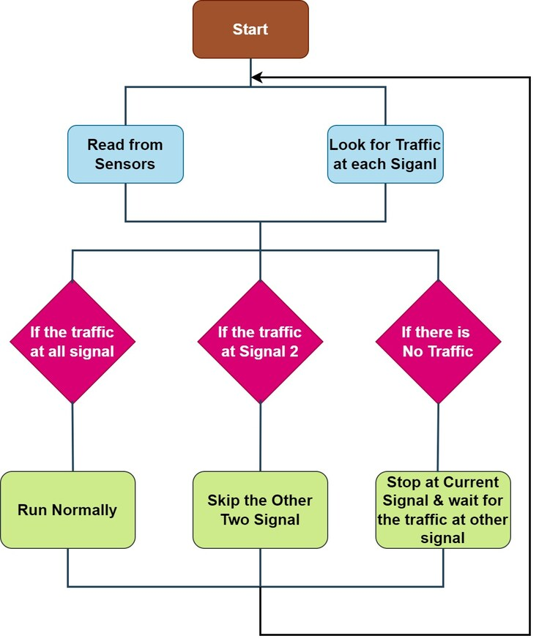

**Fig 2.2.1 Block Diagram For Application**

**CHAPTER 3**

**KEY PHASES OF DESIGN THINKING**

**3.1 Empathize**

The first phase of Design Thinking is Empathize, which focuses on understanding the users, their needs, and their challenges. The goal is to gather deep insights into the user's experiences and emotions, which will later inform the design process.

**Key Elements of Empathizing:**

* **User Research:** The primary method of empathizing with users is through research, which may include interviews, surveys, observations, and direct interactions. Understanding the users' environment, behaviors, and pain points allows designers to better frame the problems they need to solve.
* **Building Rapport:** Establishing a relationship with users is essential to obtain honest and valuable feedback. Active listening and building trust with users help designers learn about their needs from a first-hand perspective.
* I**mmersion:** Immersing oneself in the user’s world allows designers to see things from the user’s point of view. This could involve shadowing, role-playing, or experiencing the challenges users face.
* **Identifying User Pain Points:** Through empathy, designers can identify the pain points users experience in their daily lives or in the specific context related to the project.

**Importance:**

The Empathize phase ensures that the design process begins with a deep understanding of users' problems and needs, setting the foundation for a user-centered design solution.

**3.2 Define**

Once enough information is gathered in the Empathize phase, the next step is to Define the problem. This phase involves synthesizing the research findings to create a clear and actionable problem statement.

**Key Elements of Defining:**

* **Problem Statement**: The problem statement is crafted to clearly define the issue in a way that is both broad enough to allow for creative solutions and narrow enough to ensure focus. A strong problem statement focuses on users’ needs and pain points.
* **Point of View (POV)**: This refers to a concise description of the user, their needs, and the key insights gained during the Empathize phase. A well-articulated POV serves as a guiding star for generating solutions.
* **Prioritization**: In many cases, a designer is faced with multiple user needs or problems. In the Define phase, the team must prioritize the most critical problems to solve based on their impact on the user and the business.
* **Reframing the Problem**: The Define phase often involves reframing the problem in different ways to get a fresh perspective. By challenging assumptions and looking at the problem from various angles, designers can gain new insights.
* **User Personas**: Another key output of this phase is the creation of user personas, which represent the key segments of users. These personas help guide decision-making and ensure that the solutions are relevant to the users.

**Importance:**

The **Define** phase clarifies the focus of the design project by narrowing down the problem, which ensures the team works toward solving the right challenge.

**3.3 Ideate**

The Ideate phase is where creativity thrives, enabling teams to brainstorm and explore innovative solutions. This phase bridges problem definition and solution development, encouraging a wide range of ideas without immediate concern for constraints or feasibility.

**Key Elements of Ideating:**

* **Brainstorming:** Structured and unstructured brainstorming techniques, such as mind mapping and sketching, help generate diverse ideas. The goal is to create a pool of potential solutions, even unconventional ones.
* **Divergent Thinking:** Teams expand their thinking by exploring various perspectives and alternative approaches, breaking traditional barriers to innovation.
* **Convergent Thinking:** After exploring possibilities, teams evaluate and refine ideas based on user needs, feasibility, and alignment with objectives, narrowing down to the most promising options.
* **Sketching and Prototyping:** Creating low-fidelity prototypes like storyboards or wireframes brings ideas to life, allowing visualization and early validation of concepts.
* **Collaborative Thinking:** Teams leverage diverse expertise and perspectives to refine ideas, fostering innovative and user-centered solutions.

**Importance:**

The Ideate phase fosters creativity, collaboration, and open thinking. By generating a variety of solutions and then focusing on the best ones, teams lay the groundwork for impactful and innovative outcomes. This phase ensures that user needs are met with practical, innovative solutions before moving into prototyping and testing. It encourages teams to consider both short-term feasibility and long-term scalability.

**3.4 Prototype**

In the Prototype phase, the team creates tangible representations of the selected ideas from the Ideate phase. Prototypes allow designers to test concepts in real-world scenarios and gather invaluable feedback to refine their solutions.

**Key Elements of Prototyping:**

* **Low-Fidelity Prototypes:** These are quick, simple, and cost-effective models such as paper sketches, wireframes, or digital mockups. The focus is on exploring functionality and usability rather than creating a final product.
* **Iterative Process:** Prototyping involves a cycle of design, test, and refinement. Each iteration incorporates feedback and insights to improve the prototype progressively.
* **Testing and Feedback:** Real users interact with the prototype to evaluate its effectiveness. Feedback gathered during these sessions helps identify usability issues, areas for improvement, and unmet user needs.
* **Failure as Learning:** A failed prototype is not a setback but a valuable learning opportunity. Each failure provides insights that drive innovation and improved design solutions.
* **Tools and Techniques:** Depending on the project, prototypes can take various forms, including physical models, app demos, or interactive websites. Tools such as wireframing software, 3D modeling tools, and simulation platforms aid the prototyping process.

**Importance:**  
 The Prototype phase bridges the gap between abstract ideas and practical solutions. By testing prototypes, teams can identify flaws early, ensuring that the final product aligns with user needs and expectations.

**3.5 Test**

The **Test** phase is where the final design is rigorously evaluated with actual users to uncover any issues and refine the design further. Testing provides valuable feedback and helps ensure the product meets the user’s needs.

**Key Elements of Testing:**

1. **User Testing**: Prototypes or final products are tested with end-users, who are asked to interact with the design. Their feedback and behavior provide critical insights into usability and functionality.
2. **Usability Testing**: During usability testing, the design is evaluated for ease of use, intuitive interfaces, and user satisfaction. Testing can involve task analysis and observation of users interacting with the design.
3. **Iterative Improvements**: Based on test results, designers make adjustments to the design, making improvements where necessary. Testing might lead to redesigning elements or revisiting earlier phases.
4. **Evaluating Effectiveness**: The team will evaluate if the design meets the problem statement and addresses the user's pain points as identified in earlier phases. Success metrics or KPIs (Key Performance Indicators) are often defined to measure the solution’s impact.
5. **Final Adjustments**: After testing, the final product is adjusted, and the design is refined to meet user needs effectively. If necessary, designers will iterate back to earlier phases, such as prototyping or ideation, to make changes based on feedback.

**Importance:**

The Test phase is critical in validating the solution. It ensures that the design works for users and solves the problems identified in the Define phase, refining the final product to its optimal version.

**CHAPTER 4**

**MODULE DESCRIPTION**

**4.1 Vehicle Detection and Classification Module**

* The Vehicle Detection and Classification Module is a core component of the AI Traffic Monitoring and Management System. It employs advanced computer vision techniques to detect and classify vehicles in real-time as they move through urban streets, highways, and intersections. This module uses cameras and sensors strategically placed throughout the traffic network to capture images or video feeds.
* Once the data is captured, it is processed using Convolutional Neural Networks (CNNs), a type of deep learning model that excels at image recognition tasks.
* In the first step, vehicle detection involves identifying vehicles within the captured frames, typically by analyzing the differences between the background and moving objects. The system must be able to accurately detect vehicles under various conditions, such as at night, in heavy traffic, or during poor weather conditions like rain or fog.
* The technology is also designed to work in real-time, processing frames quickly enough to capture fast-moving vehicles without lag. Vehicle detection algorithms must be highly accurate to avoid false positives or missed detections that could lead to poor system performance or traffic mismanagement.
* Once vehicles are detected, the module classifies them into different categories. This could include basic vehicle types such as cars, trucks, buses, motorcycles, and bicycles. More advanced systems may also classify vehicles by make and model.

**4.2 Automated Number Plate Recognition (ANPR) Module**

* The Automated Number Plate Recognition (ANPR) Module is an integral component of modern traffic monitoring systems. Its primary function is to automatically detect and interpret vehicle license plates, enabling the system to identify and track vehicles as they move through the monitored area. ANPR is commonly used in traffic law enforcement, toll collection, and vehicle tracking applications. In the AI Traffic Monitoring and Management System, this module plays a critical role in improving road safety and ensuring compliance with traffic laws.
* ANPR systems work by capturing high-resolution images of vehicles and using optical character recognition (OCR) technology to extract the alphanumeric characters on the license plate. The images are typically taken from cameras positioned at key locations such as intersections, toll booths, or highway entry points. These cameras use high-speed shutters and powerful image sensors to capture clear images, even under challenging conditions such as nighttime or poor weather.
* Once the images are captured, the ANPR system processes them using machine learning and computer vision algorithms. The first step is to detect the number plate, which involves identifying the plate’s location in the image. The system then isolates the license plate from the rest of the vehicle and uses OCR algorithms to read the characters. These characters are then matched against a database, where they are cross-referenced with vehicle registration data or violation records. For example, if a vehicle is detected running a red light or speeding, its license plate is logged, and the system generates an alert for traffic authorities.

**4.3 Traffic Flow ant Optimization Module**

The Traffic Flow and Optimization Module is a crucial component in modern traffic management systems, designed to enhance traffic flow, reduce congestion, and optimize transportation infrastructure. By leveraging real-time data from sensors, cameras, and GPS devices, the module continuously monitors traffic conditions such as vehicle counts, traffic speeds, and congestion levels. It uses artificial intelligence (AI) and machine learning algorithms to dynamically adjust traffic signal timings, ensuring smoother traffic movement and reducing delays at intersections.

The system also integrates with navigation apps to provide optimized route suggestions, helping drivers avoid congested areas and distribute traffic more evenly across the network. Predictive models analyze historical and real-time data to anticipate potential traffic bottlenecks and take proactive measures to avoid congestion. Additionally, the module detects traffic incidents like accidents or road blockages and adjusts traffic flow or reroutes vehicles accordingly, ensuring a faster emergency response.

By balancing vehicle flow across different routes and integrating various transportation modes, such as public transport and private vehicles, the module optimizes urban mobility. Ultimately, this system reduces travel time, fuel consumption, and emissions, contributing to a more sustainable and efficient urban transportation environment. The Traffic Flow and Optimization Module represents a significant advancement in managing complex urban traffic systems, improving both the efficiency of transportation networks and the overall quality of urban life.

**CHAPTER 5**

**CONCLUSION**

The AI Traffic Monitoring and Management System is a transformative solution for modernizing traffic management and enhancing urban mobility. Through its innovative modules, such as Vehicle Detection and Classification, Automated Number Plate Recognition (ANPR), and Traffic Flow Prediction and Optimization, the system offers significant improvements in road safety, traffic efficiency, and overall city infrastructure management.

The Vehicle Detection and Classification Module provides a real-time analysis of traffic conditions by accurately detecting and classifying vehicles. This functionality not only helps optimize traffic signal timings but also assists in identifying patterns in traffic flow, which can lead to better decision-making regarding urban planning and infrastructure development. By integrating with other modules, this module forms the backbone of a cohesive traffic management system, where vehicle types are considered for more personalized traffic control strategies.

The ANPR Module automates the process of vehicle identification, crucial for enforcing traffic laws and ensuring compliance. This technology improves the efficiency of law enforcement by eliminating manual checks and providing real-time data on violations such as speeding or illegal parking. Moreover, the integration of ANPR with vehicle tracking systems enhances public safety and allows for swift responses to criminal activities or stolen vehicle detections.

**REFERENCES**

* 1. Zhang, Y., & Wei, X. (2019). *Traffic flow prediction using machine learning methods: A review*. Journal of Transportation Engineering, Part A: Systems, 145(12), 04019065. https://doi.org/10.1061/JTEPBS.0000217
  2. Bauza, R., & Gersch, L. (2020). *Application of automated vehicle recognition systems in intelligent traffic management*. International Journal of Traffic and Transportation Engineering, 15(2), 141-153.
  3. Kang, H., & Lee, S. (2021). *Real-time vehicle detection and classification using deep learning for urban traffic management*. Journal of Intelligent Transportation Systems, 25(3), 254-268. https://doi.org/10.1080/15472450.2021.1895000
  4. Roth, D., & Grant, M. (2018). *Optimizing traffic light control in smart cities using predictive algorithms*. Journal of Smart Cities and Mobility, 2(4), 104-119.
  5. Zhang, S., & Liu, X. (2020). *Automated number plate recognition (ANPR) systems: Current state and challenges*. International Journal of Computer Science and Applications, 17(1), 45-58.
  6. Amin, S., & Al-Mohannadi, H. (2022). *AI-driven traffic flow prediction and optimization for urban mobility*. International Journal of Artificial Intelligence in Transportation, 6(2), 115-130.
  7. Liu, Y., & Li, Z. (2021). *AI-powered traffic surveillance and control systems for smart cities*. Smart Cities Journal, 8(3), 111-124.
  8. Xia, J., & Chen, T. (2020). *Vehicle detection and tracking algorithms for intelligent traffic systems: A survey*. Journal of Traffic and Transportation Engineering, 10(4), 1012-1027.
  9. Patel, A., & Kumar, R. (2021). *Advances in traffic management systems for smart cities using IoT and AI technologies*. Proceedings of the International Conference on Intelligent Systems, 6(2), 230-245.

**APPENDIX – A**

**SCREENSHOTS**

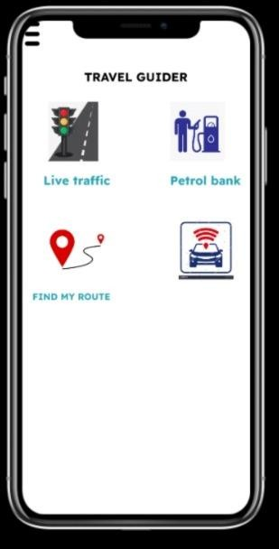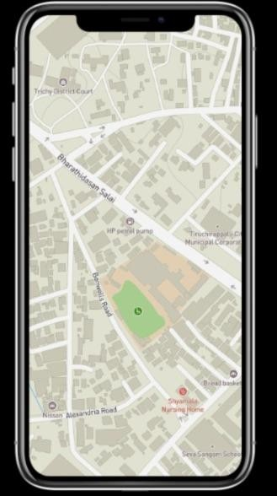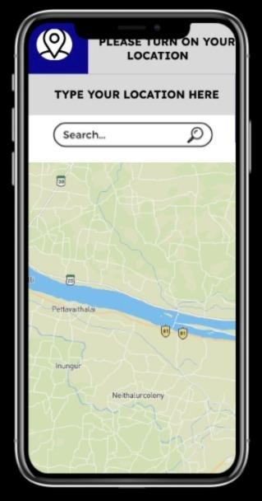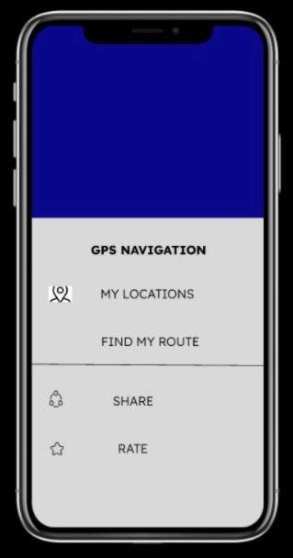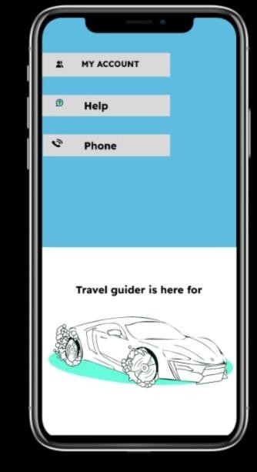

Fig A.1 Application Interfaces